**Over The Wire**

## Level 11 to Level 12

**Step 1: SSH Login**

**Password**: dtR173fZKb0RRsDFSGsg2RWnpNVj3qRr

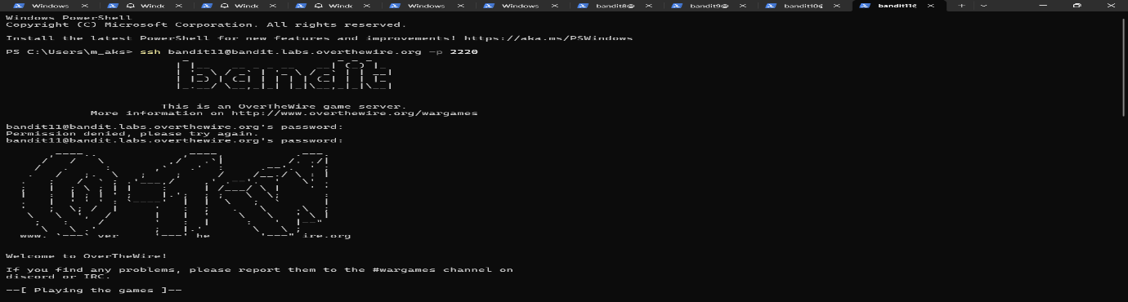

**Step 2:**

**Cat data.txt**

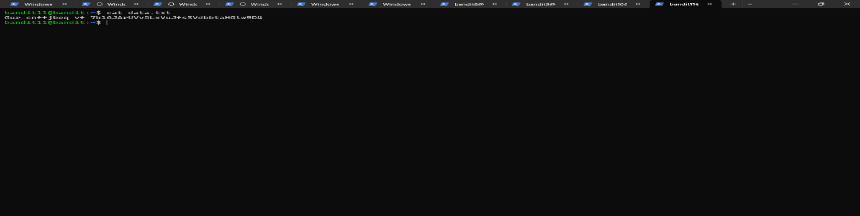

**Step 3: Decode ROT13**

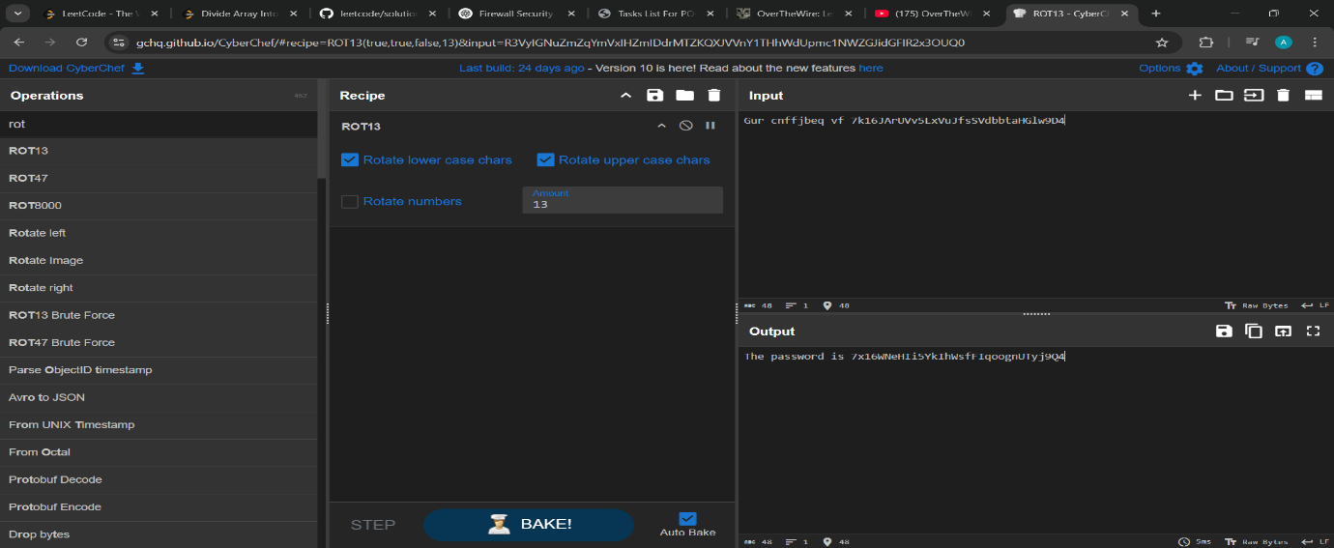

**The password is 7x16WNeHIi5YkIhWsfFIqoognUTyj9Q4**